1.3) Concerning the following program, which of the following statements is incorrect?`

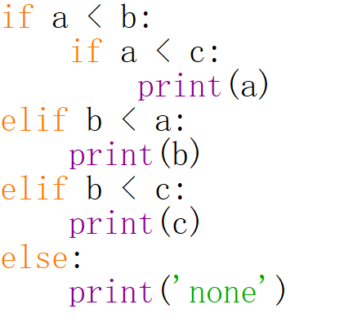

1. print(‘none’) will be executed when $a, b, c=20, 30, 10$.
2. print(b) will be executed when $a, b, c =20, 15, 10$.
3. print(c) will be executed when $a, b, c =10, 10, 20$.
4. print(a) will be executed when $a, b, c =10, 20, 30$.

Answer: A

1.4) Concerning the object in Python, which of the following statements is incorrect?

1. Every object in Python has a unique ID.
2. The type of an object is determined automatically by Python interpreter according to its value.
3. Every variable is essentially a reference to an object.
4. The ID of an object may be changed during the execution of the program.

Answer: D

2.2) Concerning the following program, which of the following statement/s is/are correct?

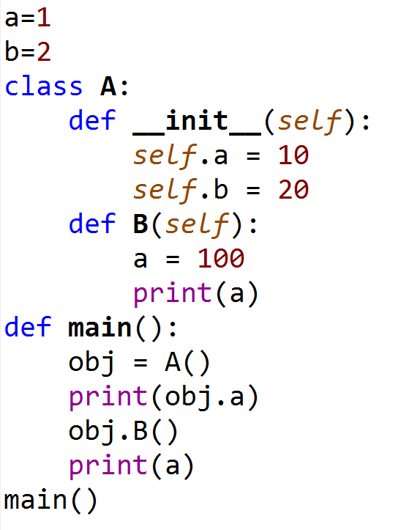

1. In this program, three different variables a have been defined.
2. Data field a of class A() can only be accessed within the class definition.
3. The value of global variable a will initially be set as 1, and then changed to 100.
4. The output of this program is

10

100

100

Answer: A